Studio-Lab 5- In Class Experiments

1. Open a canvas that is 8 inches X 11 inches and select RGB color, 8-bits, and 72 resolution.
Schools of design often teach that certain colors invoke certain emotions. For example:
Red – hot and exciting
Blue – cold and icy
Orange and yellow – warm and inviting
Green and turquoise – soothing and calm
Also,
Light or pale colors are gentle and relaxing
Dark colors are serious and confining
Bright colors are attention getters

Experiment with different colors by creating splashes of color using the brush tool and making different color selections.
Pretend that you are designing a web site that is targeted for a specific audience. Examples might be a site for children, a trendy night-club, yoga classes, or sports fans. (You may make up any type of audience you wish). Choose your colors to reflect the audience and make a .jpg file of the result. Use the text tool to state what the audience is. Don’t spend a lot of time on this, but do 3 different .jpg files and email them to cpscgrader@hiram.edu during the class time with the subject header of Swatches. I am mainly interested in seeing that you can make color selections that convey some kind of emotion. (I won’t assign a grade to these unless you fail to do the exercise.)
An (easy) example:

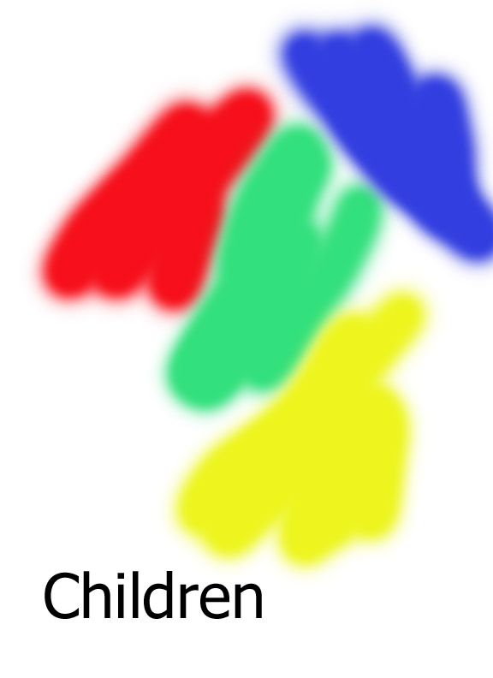

2. Experiment with the various image adjustment techniques on the images linked off of the web site. See if you can improve the images provided. In a few cases I have provided names such as Bad… and Good…. See if you can transform the Bad image into something like the Good image. For the other images, see if you can make them appear more realistic.
3. Experiment with the various filter adjustments on any of the images you wish. The more you experiment now, the easier it will be for you to make decisions about your montage.
4. If you have time, play with the Retouch tools mentioned.

